Mini Project 1

Matthew Lynn

**Section 1**

1. Our initial step was to fit our KNN model with values of k = [1,2,…,30,35,…,100]
2. 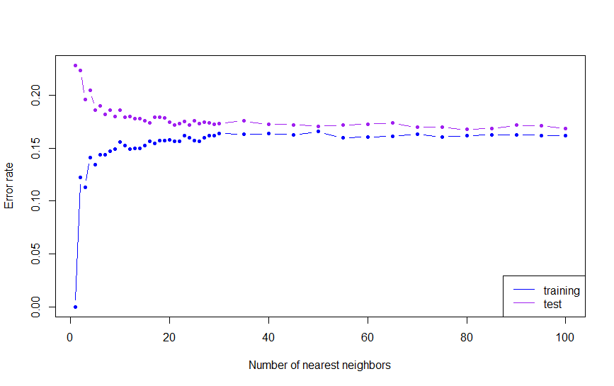The next goal was to plot test error rate and training error rate against k and compare the rates. We should expect a U-shape on the test error rate from bias-variance tradeoff. We should also expect training error rate to increase as k reaches higher values. This is due to the KNN model becoming less flexible therefore increasing bias.

As expected, our test error rate decreases as our KNN model becomes more flexible. However, the U-shape is hard to determine here which may be due to small values of k. Training error rate increased as flexibility increased and then went sideways. It is consistent with what we expected except for the shape of our training error rate. Interestingly, we will see that our optimal k value is in between our end points which imply a very flat U-shape.

1. The optimal value of k is achieved when we take the min(test error rate). We look to the values of k that correspond to the min(test error rate) and training error rate. Below is a snippet of the output.

ks err.rate.train err.rate.test

80 0.1615 0.1675

Here we see that test error rate (0.1675) is minimized at k = 80, and the corresponding training error rate is 0.1615.

1. 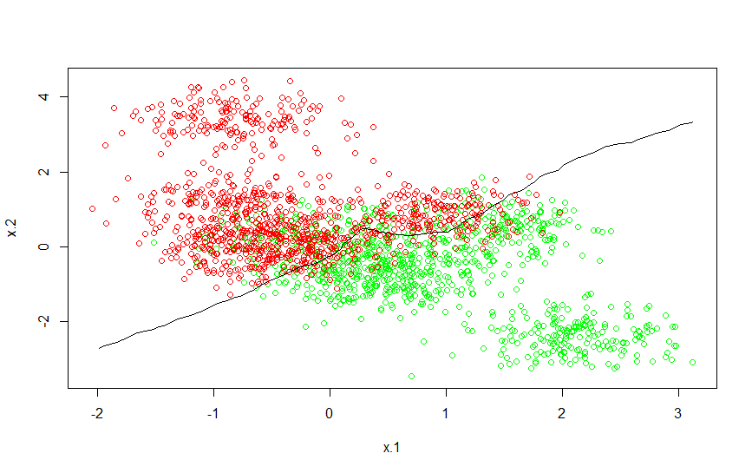Below is a plot of our data that show observations painted green when the response is “yes” and painted red otherwise (“no”).

The black line denotes the decision boundary (at optimal k = 80) between the responses “yes” and “no.” Right away we notice that many of the red and green observations overlap the line, this is due to the bias-variance tradeoff. We take a hit on variance and choose a more flexible model to help diminish bias. However, the plot clearly shows which areas are “yes” (green) and “no” (red). Therefore, the decision boundary line does a good job splitting the two clusters. It is very sensible and easy to interpret visually.

**Section 2**

R-code

# Mini Project 1

# Matthew Lynn

# First we want to bring in our data sets for training and testing----

train = read.csv("1-training_data.csv", header = T) test = read.csv("1-test_data.csv", header = T)

# Lets take a look at the data

# First we use the head() to check a snippet of our columns and what kind of obs we are dealing with

# Then we use str() to determine the data types of each column

# Based on head() and str() we see that x.1 and x.2 are quantitative and y is qualitative # Summary() gives us some quick stats and shows us that our y variable is 50/50 with yes and no obs

head(train) str(train) summary(train)

# Now we want to look at a scatterplot of every variable

# Also we'd like to see what our correlation matrix looks like # It appears that x.1 and x.2 have a negative trending correlation

pairs(train) round(cor(train[,-3]), 3)

# Lets use y as the response variable and the remaining variables as predictors attach(train)

# want to double check that the dimensions and columns are correct

train.x = cbind(x.1, x.2) dim(train.x) head(train.x)

train.y = y head(train.y) table(train.y)

# Now lets plot out or training data plot(train.x, xlab = "x.1", ylab = "x.2", col = ifelse(train.y == "yes", "green", "red"))

# Lets set up our test data attach(test)

test.x = cbind(x.1, x.2) test.y = y

# A quick glance at the Global Environment window lets use know that all our dimensions are good to go

# Now we can answer some questions

# Question 1 part a----

# The goal for question 1 is to fit KNN for K = 1:30 by 1 and 35:100 by 5 library(class)

# Lets set up a variable so that we can fit KNN for several values of K

# Then we set up our error rates to be fed into a loop along ks

# The names part forces the column headers of the error rates and ks to be the same

# This way they are easier to read in a table as well as functions that call them against each other

ks = c(seq(1, 30, by = 1), seq(35, 100, by = 5)) nks = length(ks) err.rate.train = numeric(length = nks) err.rate.test = numeric(length = nks) names(err.rate.train) = names(err.rate.test) = ks

# Now we iterate along each value of ks to produce a set of error rates

for (i in seq(along = ks)) { set.seed(160230)

mod.train = knn(train.x, train.x, train.y, k = ks[i]) set.seed(160230)

mod.test = knn(train.x, test.x, train.y, k = ks[i]) err.rate.train[i] = 1 - sum(mod.train == train.y)/length(train.y) err.rate.test[i] = 1 - sum(mod.test == test.y)/length(test.y) }

# here we plot the test and training errors together

plot(ks, err.rate.train, xlab = "Number of nearest neighbors", ylab = "Error rate", type = "b", ylim = range(c(err.rate.train, err.rate.test)), col = "blue", pch = 20) lines(ks, err.rate.test, type="b", col="purple", pch = 20)

legend("bottomright", lty = 1, col = c("blue", "purple"), legend = c("training", "test"))

# Now we want to find the optimal k using a min function

result <- data.frame(ks, err.rate.train, err.rate.test) result[err.rate.test == min(result$err.rate.test), ] # Now we want to make a decision boundary

n.grid <- 50 x1.grid <- seq(f = min(train.x[, 1]), t = max(train.x[, 1]), l = n.grid) x2.grid <- seq(f = min(train.x[, 2]), t = max(train.x[, 2]), l = n.grid) grid <- expand.grid(x1.grid, x2.grid)

# we set the optimal k found above and modify the attribute "prob" from mod.opt to feed us the "yes" obs only # to be used on the contour that lays over x.1 and x.2

k.opt <- 80 set.seed(1) mod.opt <- knn(train.x, grid, train.y, k = k.opt, prob = T) prob <- attr(mod.opt, "prob") # prob is voting fraction for winning class prob <- ifelse(mod.opt == "yes", prob, 1 - prob) # now it is voting fraction for Direction == "Up" prob <- matrix(prob, n.grid, n.grid)

plot(train.x, col = ifelse(train.y == "yes", "green", "red"))

contour(x1.grid, x2.grid, prob, levels = 0.5, labels = "", xlab = "", ylab = "", main = "", add = T